**Behavioral Data**

* Toss criteria: Dropping any subject w/ numTrialsCompleted < 200 or > 250.
* Analyzed with R.
* model=glmer(Choice~MFonMB+(1|Subj)+(0+MFonMB|Subj),family=binomial,data=data_crits);model_all=glmer(Choice~MB+MF+MFonMB+(1|Subj)+(0+MB+MF+MFonMB|Subj),family=binomial,data=data_crits)  
  model_unlikely=glmer(Choice~Unlikely+(1|Subj)+(0+Unlikely|Subj),family=binomial,data=data_unlikely)
* MB and MF in model_all have no distance cutoff, but are time-discounted (gamma = .85)

***Baseline***

Dropped 14 subjects  
218 subjects  
6120 congruent observations, 539 unlikely observations

**model:**

Converged  
MFonMB estimate = 0.12276  
Wald z-test: SE = 0.01039, z = 11.815, p <2 e-16  
LRT: Chisq = 379.9, df = 2, p < 2.2e-16  
Bootstrapping: 0 out of 1000

**model_all (w/o time discounting):**

Converged  
MFonMB estimate = 0.14931  
Wald z-test: SE = 0.01208, z = 12.358, p <2 e-16  
LRT: Chisq = 359.37, df = 4, p < 2.2e-16

**model_all (w/ time discounting):**

Did not converge  
MFonMB estimate = 0.14949  
Wald z-test: SE = 0.01211, z = 12.344, p <2 e-16  
LRT: Chisq = 354.26, df = 4, p < 2.2e-16  
Bootstrapping: 0 out of 1000

**model_unlikely:**

Converged  
Unlikely estimate = 0.18920

**t-test:**

Mean choice when MFonMB > 0: 0.5700124  
Mean choice when MFonMB < 0: 0.4121198  
Difference = 0.1578926  
t-test: t = -8.4955, df = 217, p-value = 3.156e-15

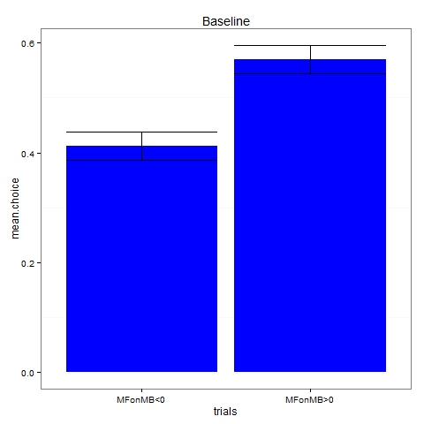

*

**t-test (unlikely):**

Mean choice when Unlikely > 0: 0.5275229  
Mean choice when Unlikely < 0: 0.3409786  
Difference = 0.1865443

***2-trial-type***

Dropped 15 subjects  
176 subjects  
2473 congruent observations, 1254 incongruent observations, 204 unlikely observations  
model_comb=glmer(Choice~MFonMB+MFonMB:Crits+(1|Subj)+(0+MFonMB+MFonMB:Crits|Subj),family=binomial,data=data_crits_comb);

**model:**

Converged  
MFonMB estimate = 0.06071   
Wald z-test: SE = 0.01208, z = 5.024, p = 5.06e-07  
LRT: Chisq = 34.951, df = 2, p = 2.573e-08  
Bootstrapping: ???

**model_incog:**

Converged  
MFonMB estimate = -0.008089   
Wald z-test: SE = 0.015035, z = -0.538, p = 0.591  
LRT: Chisq = 0.2894, df = 2, p= 0.8653

**model_comb:**

Converged  
MFonMB estimate (incongruent trials) = -0.00791   
Wald z-test: SE = 0.01516, z = -0.522, p = 0.601901  
MFonMB:Crits estimate (congruent trials) = 0.06964   
Wald z-test: SE = 0.01936, z = 3.598, p = 0.000321  
LRT: Chisq = 16.463, df = 3, p = 0.0009114  
Bootstrapping: ???

**model_all (w/o time discounting):**

Didn’t converge, but close (maxgrad = .005)  
MFonMB estimate = 0.06157  
Wald z-test: SE = 0.01416, z = 4.347, p = 1.38e-05  
LRT: Chisq = 21.739, df = 4, p = 0.0002258  
Bootstrapping: ???

**model_all (w/ time discounting):**

Didn’t converge, but close (maxgrad = .007)  
MFonMB estimate = 0.06186  
Wald z-test: SE = 0.01424, z = 4.345, p = 1.39e-05  
LRT: Chisq = 20.316, df= 4, p = 0.0004326  
Bootstrapping: ???

**model_unlikely:**

Converged  
Unlikely estimate = 0.24018

**t-test (congruent):**

Mean choice when MFonMB > 0: 0.5148211  
Mean choice when MFonMB < 0: 0.4682376  
Difference = 0.04658353  
t-test: t = -2.025, df = 175, p-value = 0.04438

**t-test (incongruent):**

Mean choice when MFonMB > 0: 0.47772612  
Mean choice when MFonMB < 0: 0.51767399  
Difference = -0.03994787  
t-test: t = 1.2934, df = 168, p-value = 0.1976

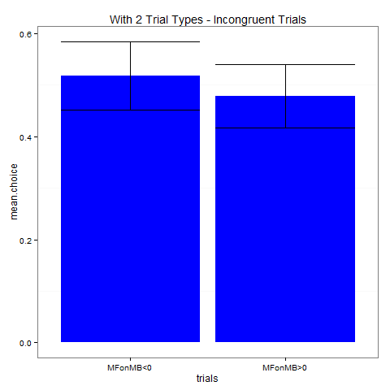

*

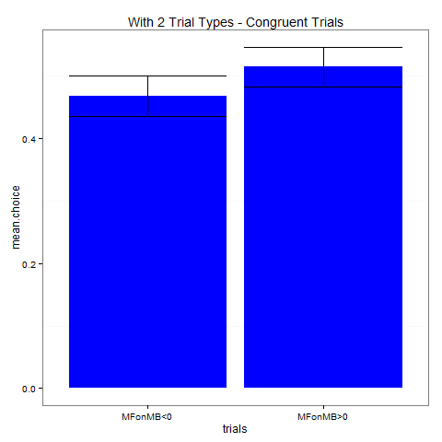

**t-test (unlikely):**

Mean choice when Unlikely > 0: 0.6328502  
Mean choice when Unlikely < 0: 0.4975845  
Difference = 0.1352657

***With A0***

Dropped 19 subjects  
293 subjects  
8086 congruent observations, 677 unlikely observations

**model:**

Converged  
MFonMB estimate = 0.106971  
Wald z-test: SE = 0.008531, z = 12.540, p < 2e-16  
LRT: Chisq = 389.47, df = 2, p < 2.2e-16  
Bootstrapping: ???

**model_all (w/o time discounting):**

Did not converge  
MFonMB estimate = 0.118580   
Wald z-test: SE = 0.009583, z = 12.374, p < 2e-16  
LRT: Chisq = 331.35, df = 4, p < 2.2e-16  
Bootstrapping: ???

**model_all (w/ time discounting):**

Did not converge, but close (maxgrad = .004)  
MFonMB estimate = 0.116199  
Wald z-test: SE = 0.009617, z = 12.082, p < 2e-16  
LRT: Chisq = 317.7, df = 4, p < 2.2e-16  
Bootstrapping: ???

**model_unlikely:**

Converged  
Unlikely estimate = 0.17825

**t-test:**

Mean choice when MFonMB > 0: 0.5506988  
Mean choice when MFonMB < 0: 0.4118604  
Difference = 0.1388384  
t-test: t = -9.0027, df = 292, p-value < 2.2e-16

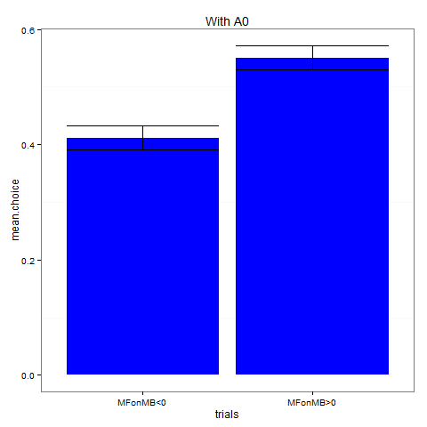

*

**t-test (unlikely):**

Mean choice when MFonMB > 0: 0.5735142  
Mean choice when MFonMB < 0: 0.3850129  
Difference = 0.1885013

**Simulations**

* 200 agents, 50 practice rounds, 175 real rounds. 26 critical trials (in 2-trial-type versions, half are incongruent).
  + Agents have 5 free parameters: learning rate, temperature, eligibility trace, model-based weight, and model-free weight. Goal weight = 1 – (model-based weight) – (model-free weight).
  + lr ~ U(0,1); temp ~ U(0,1.5); elig ~ U(.5,1); all weights ~ U(0,1) and then normalized. (For “No MF-goal” versions, goal weight = 0.)
  + Agents implement ??? for model-based learning and SARSA for model-free learning. Simple version of SARSA for MF-goal.
* Rewards/transitions are randomly generated the same way as in the behavioral experiments

***Baseline – no MF-goal***

**model:**

Converged  
MFonMB estimate = 0.015150  
Wald z-test: SE = 0.007763, z = 1.952, p = .051  
LRT: Chisq = 7.1524, df = 2, p = 0.02798  
Bootstrapping: ???

**model_all:**

Converged  
MFonMB estimate = 0.006092  
Wald z-test: SE = 0.008707, z = 0.7, p = 0.484  
LRT: Chisq = 1.6649, df = 4, p = 0.7971  
Bootstrapping: ???

**t-test:**

Mean choice when MFonMB > 0: 0.499101567  
Mean choice when MFonMB < 0: 0.500844882  
Difference = -0.001743315  
t-test: t = 0.1162, df = 199, p-value = 0.9076

***Baseline – with MF-goal***

**model:**

Converged  
MFonMB estimate = 0.076779  
Wald z-test: SE = 0.009167, z = 8.376, p < 2e-16  
LRT: Chisq = 130.23, df = 2, p = 0.05472  
Bootstrapping: ???

**model_all:**

Converged  
MFonMB estimate = 0.08866  
Wald z-test: SE = 0.01094, z = 8.106, p = 5.25e-16  
LRT: Chisq = 127.47, df = 4, p < 2.2e-16  
Bootstrapping: ???

**t-test:**

Mean choice when MFonMB > 0: 0.5580286  
Mean choice when MFonMB < 0: 0.4485901  
Difference = 0.1094384  
t-test: t = -6.7639, df = 199, p-value = 1.462e-10

***2-trial-type – no MF-goal***

**model (congruent):**

Converged  
MFonMB estimate = -0.006737  
Wald z-test: SE = 0.010540, z = -0.639, p = .523  
LRT: Chisq = 1.4927, df = 2, p = 0.4741  
Bootstrapping: ???

**model (incongruent):**

Converged  
MFonMB estimate = 0.0002748  
Wald z-test: SE = 0.0145705, z = 0.019, p = 0.985  
LRT: Chisq = 0.0256, df = 2, p = 0.9873  
Bootstrapping: ???

**model_comb:**

Converged  
MFonMB estimate = 0.0006886  
Wald z-test: SE = 0.0146481, z = .047, p = 0.963  
MFonMB:Crits estimate = -0.0077788  
Wald z-test: SE = 0.0182107, z = -.427, p = 0.669  
LRT: Chisq = 1.0384, df = 3, p = 0.792  
Bootstrapping: ???

**model_all:**

Did not converge, but close (maxgrad = .003)  
MFonMB estimate = -0.01800  
Wald z-test: SE = 0.01169, z = -1.540, p = 0.124  
LRT: Chisq = 5.9321, df = 4, p = .2043  
Bootstrapping: ???

**t-test (congruent):**

Mean choice when MFonMB > 0: 0.4873222   
Mean choice when MFonMB < 0: 0.5086209  
Difference = -0.0212987  
t-test: t = 0.9784, df = 199, p-value = 0.3291

**t-test (incongruent):**

Mean choice when MFonMB > 0: 0.50378673   
Mean choice when MFonMB < 0: 0.51545086  
Difference = -0.01166413  
t-test: t = 0.3554, df = 187, p-value = 0.7227

***2-trial-type – with MF-goal***

**model (congruent):**

Converged  
MFonMB estimate = 0.080374  
Wald z-test: SE = 0.011140, z = 7.215, p = 5.4e-13  
LRT: Chisq = 66.406, df = 2, p = 3.803e-15  
Bootstrapping: ???

**model (incongruent):**

Converged  
MFonMB estimate = 0.002133  
Wald z-test: SE = 0.014628, z = 0.146, p = 0.884  
LRT: Chisq = 0.0213, df = 2, p = 0.9894  
Bootstrapping: ???

**model_comb:**

Converged  
MFonMB estimate = 0.003518  
Wald z-test: SE = 0.014536, z = 0.242, p = 0.809  
MFonMB:Crits estimate = 0.076913  
Wald z-test: SE = 0.018686, z = 4.116, p = 3.85e-05  
LRT: Chisq = 21.998, df = 3, p = 6.528e-05  
Bootstrapping: ???

**model_all:**

Did not converge, but close (maxgrad = .005)  
MFonMB estimate = 0.096890  
Wald z-test: SE = 0.013101, z = 7.396, p = 1.41e-13  
LRT: Chisq = 87.075, df = 4, p < 2.2e-16  
Bootstrapping: ???

**t-test (congruent):**

Mean choice when MFonMB > 0: 0.5640002  
Mean choice when MFonMB < 0: 0.4277374  
Difference = 0.1362628  
t-test: t = -6.3025, df = 199, p-value = 1.849e-09

**t-test (incongruent):**

Mean choice when MFonMB > 0: 0.527813661  
Mean choice when MFonMB < 0: 0.518325735  
Difference = 0.009487926  
t-test: t = -0.3033, df = 187, p-value = 0.762